**BW**

Bright World

Our dream is to fulfil your World with our Lightning

Certification:-

This is to mention that

Mr.Muhammad Allian Student 1399837

Mr. Muhammad Samama Student 1400306

Mr. Ali Raza Student 1402938

Has Successfully Designed and developed their website for Wilson Sporting Goods.

**Submitted by:**

_________________________________________

**Date of issue:**  8-February-2023

**Authorized Signature:**

_________________________________________

Table of Contents:-

**Acknowledgement 4**

**Synopsis5**

**Analysis6**

**Designs7**

**DFD’s7**

**FlowCharts8**

**Process Diagrams8**

**Screen Shot’s9**

**Source Code with Comments10**

Acknowledgement:-

I would like to acknowledge all those who have given moral support and helped us to make this project

I express my gratitude to the project team and other staff members at Aptech, who guided and helped us, which I will never forget. We truly appreciate you and the time you spent helping us with this project. I enjoyed every minute of your lecture as well as your marvellous sense of humour. Through this project, we learned a lot.

I also express my sincere gratitude to our class teacher Sir Abdul Wahab Amir for helping and guiding us throughout the project and for his support and encouragement throughout the process.

I would like to offer many thanks to all my colleagues for their valuable suggestions and constructive feedback.

Synopsis:-

Bright World is about lights and needs a website to display its products and manage its business.

The company wants its website to show all its products and give its customers an easy way of choosing and purchasing their products.

Analysis:-

The web application is made by keeping all the requirements and specifications keeping in mind.

1. On the landing page, on top we have a Navbar containing Home, Brands, Gallery, Contact us, About us and Feedback page links.
2. Home page is the main landing page of the website containing all the basic information regarding the web application.
3. A picture slider and some hover effects are used on the home page to provide the user with a much more elegant and user-friendly UI.
4. The Website is featuring three light brands named Philips, Syska and Pak lights, having 16 products for each brand. The website is offering 45 products altogether.
5. On the Brands page user can easily find the brand in which they have an interest.
6. On the Gallery page, the user can see the all pictures of the products we have.
7. The user can see brief details regarding the products on the product cards. Full details are also provided for an individual product which the user can see or download through the download icon.
8. On the About us page the user can see brief details about our web, our employees and our brand partners by clicking branded icons.
9. On the Contact us page, there is a form through which the users can send their messages to the organization in case he/she has a complaint, etc.
10. By clicking on Feedback the form will pop up on the screen through that form the user can give us Feedback regarding our website.

Designs

DFD’s:-

CUSTOMER

Product Info

Drop Product

Buy Product

New Product Info

Customer Info

Bright

World

Buy/Drop Product

ADMIN

FlowChart and Process Diagrams:-

Feedback

Order

Placed

Download

Add

To

Cart

Buy

Now

Visit Website

Select

Product

Screen Shots of Our Website:-

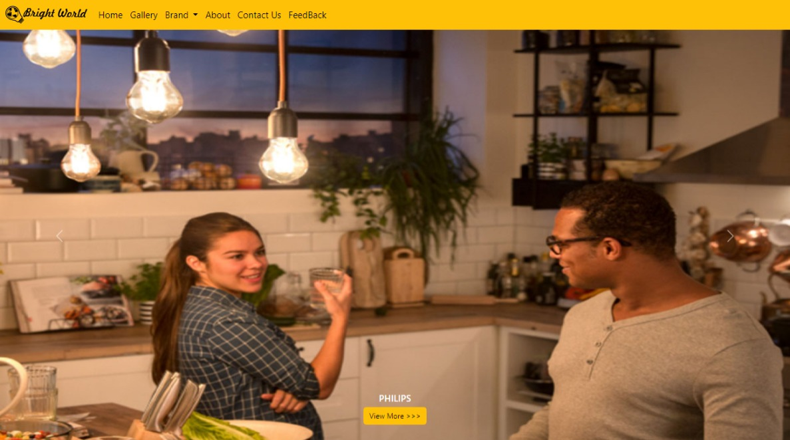

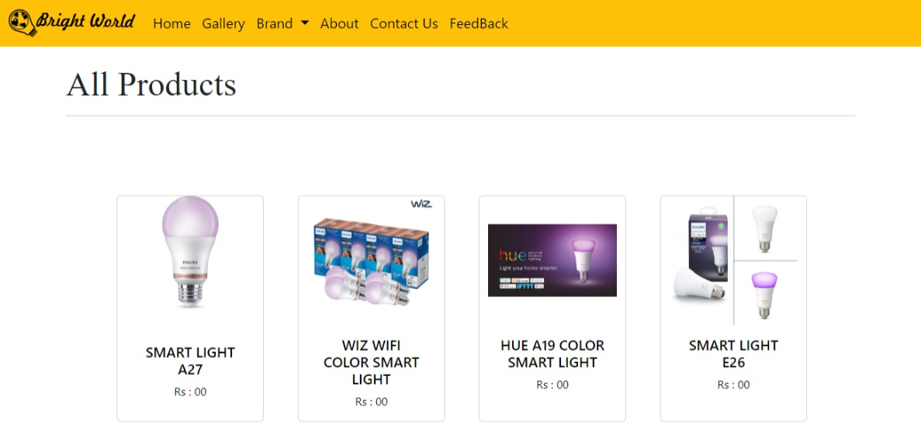

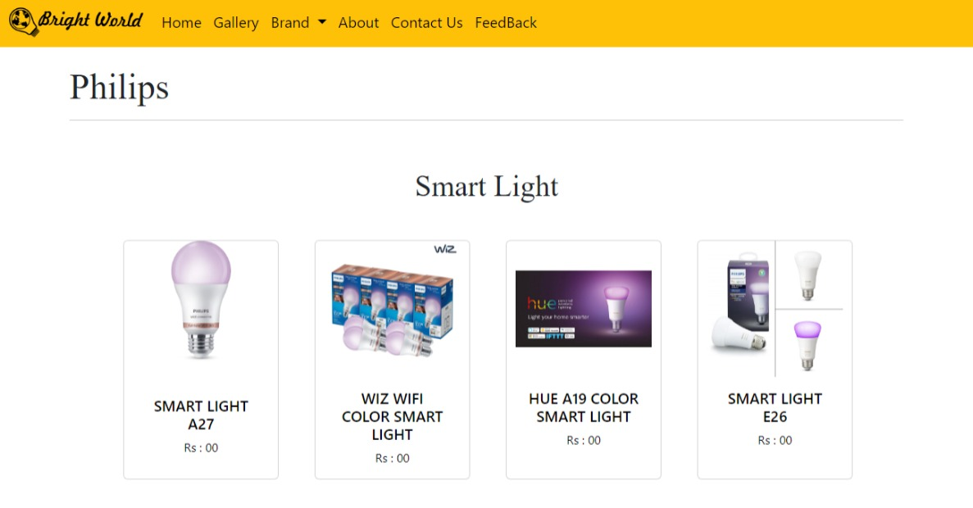

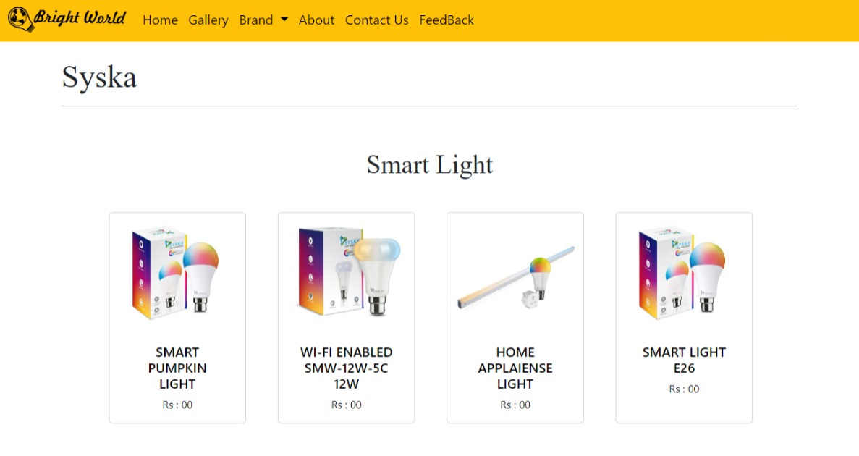

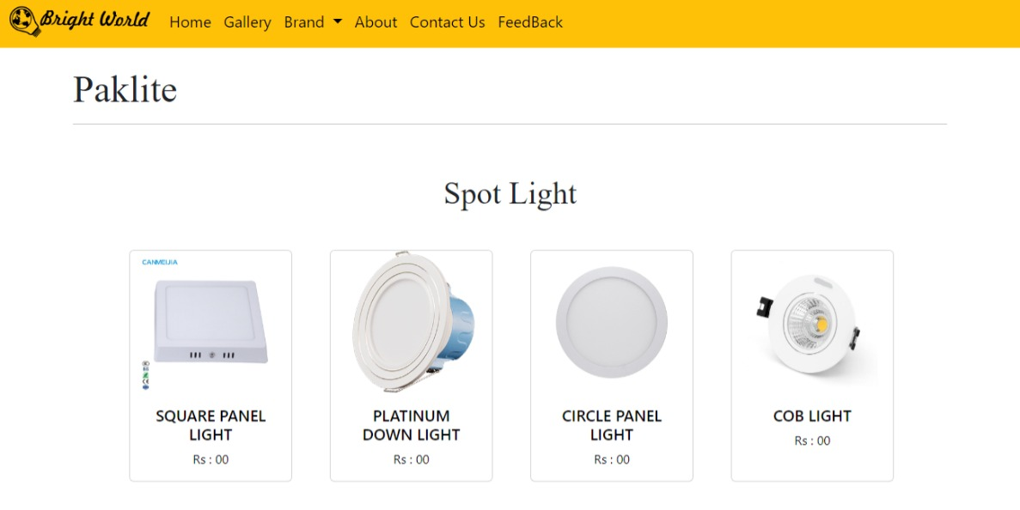

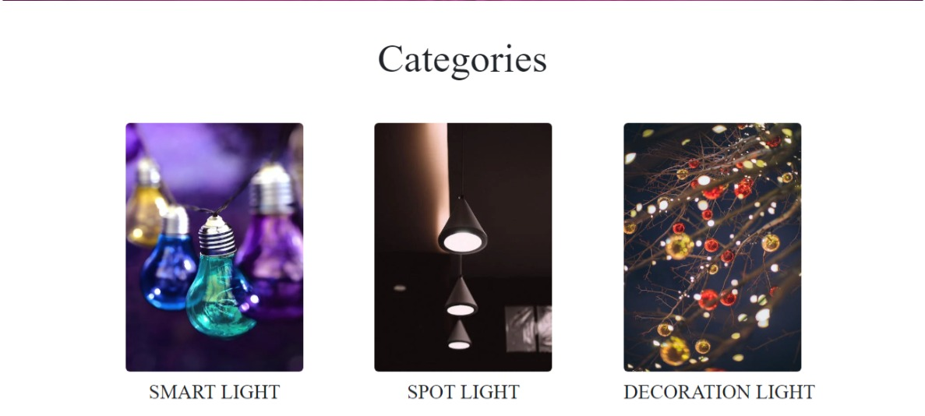

Source Code with Comments:-

2

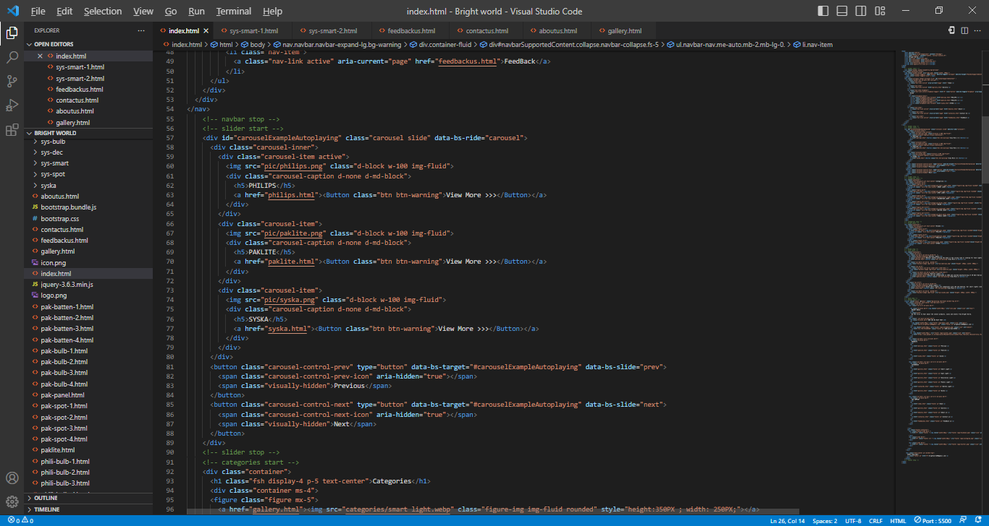

1

5

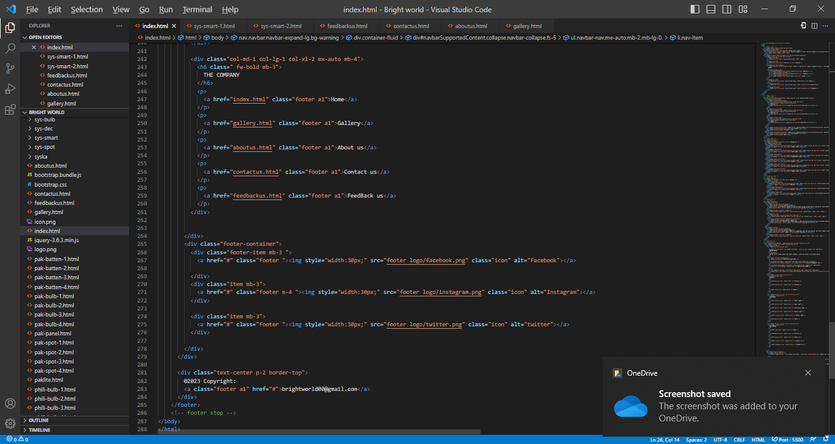

4

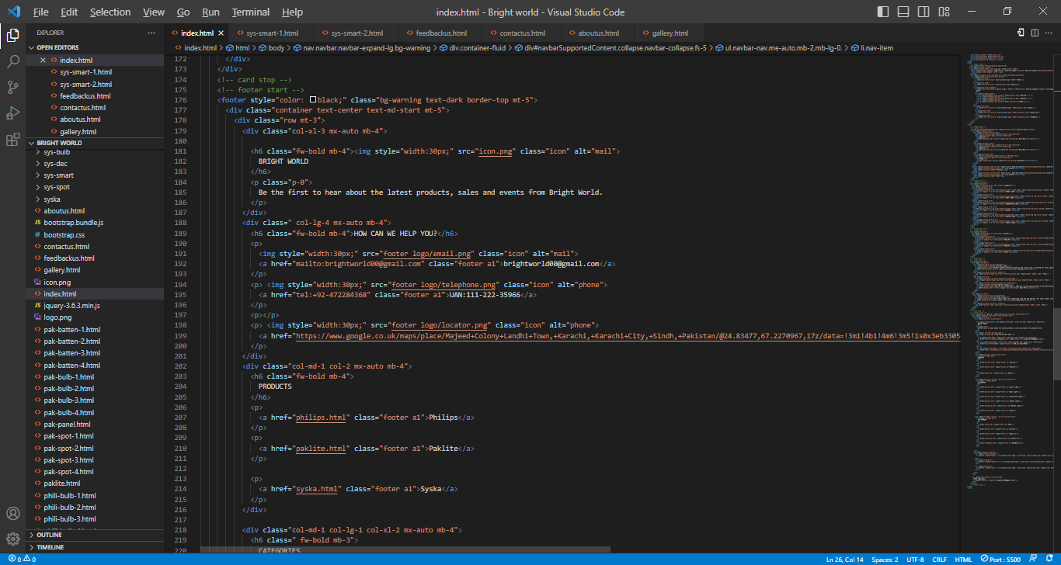

3

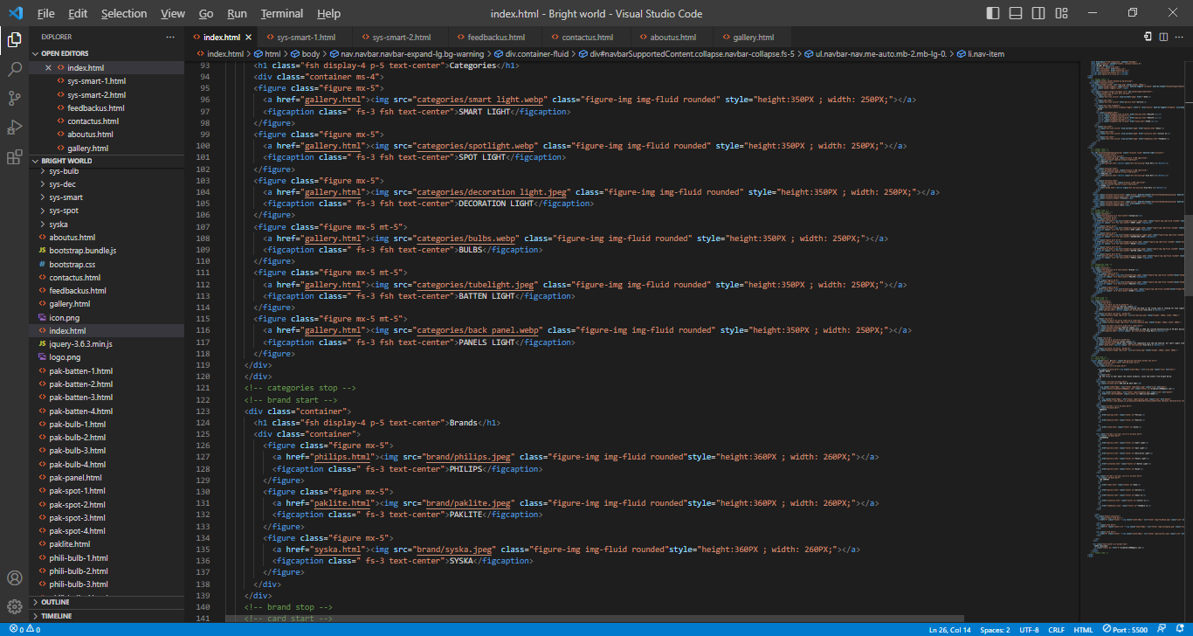

1

